Guided Capstone Project Report

Big Mountain Resort has recently installed an additional chair lift to help increase the distribution of visitors across the mountain. This additional chair increases their operating costs by $1,540,000. Big Mountain suspects it may not be maximizing its returns, relative to its position in the market. Because of this the business is looking into ways to select a better value for their ticket price. We will look into different ways to change that and hope they will either cut costs without undermining the ticket price or will support an even higher ticket price.

We looked into four potential scenarios for either cutting costs or increasing revenue (from ticket prices). The first scenario we looked into permanently closing down up to 10 of the least used runs.

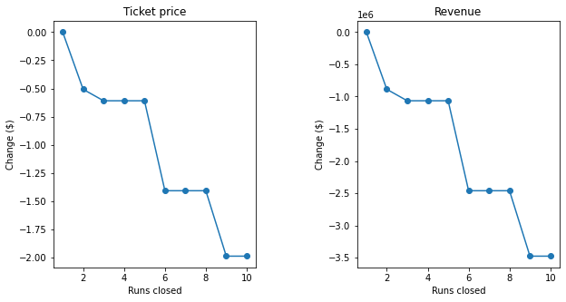

From the two models, they show that closing one run makes no difference. Closing 2 and 3 reduces support for ticket price and revenue. Closing 3, 4, and 5 seem to be no further loss in ticket price. However, closure of 6 or more leads to a large drop. In scenario 2 we add another run but increasing the vertical drop by 150 feet and installing an additional chair. This would increases support for ticket price by $10.10. Over the season the expected amount would be $176777909. In scenario 3 we would be doing the same process as scenario 2 but this time we would add 2 acres of snow making. The support ticket price would be $11.10 and the expected amount over the season would be $19427790. Therefore, small increase in snow making makes no difference. The last scenario calls for increasing the longest run by 0.2 miles and guaranteeing its snow coverage by adding 4 acres of snow making capability. This makes no difference.

Therefore, the logical direction to increase in revenue is to add another run and increasing the vertical drop by 150 feet. Even though adding 2 acres makes a little difference, we can probably add more than 2 acres to make it more of an impact.